Lesson 04 Demo 02

Configuring Apache Web Server Using Ansible

Objective: To configure and validate the setup of the Apache web server using Ansible on a local node machine for automated server management
Tools required: Linux terminal
Prerequisites: None

Steps to be followed:
- Establish connectivity between the Ansible controller and node machine
- Configure and validate the Apache web server setup

Step 1: Establish connectivity between the Ansible controller and node machine

- Run the following command to generate a new SSH key pair using the RSA encryption algorithm:
ssh-keygen -t rsa
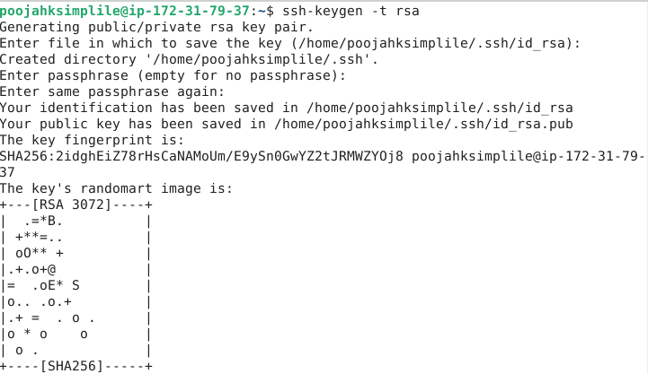
- Run the following command to append the public key to the authorized_keys file:
cat .ssh/id_rsa.pub >> .ssh/authorized_keys
- Connect to localhost via SSH port 22 using the below command:
ssh localhost -p 22
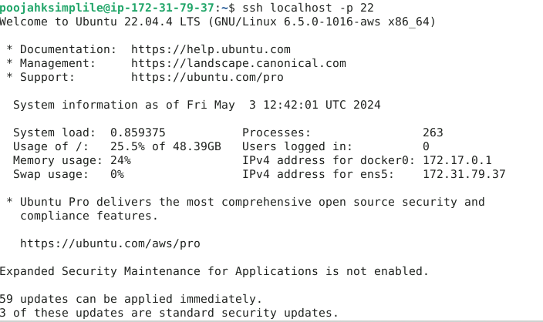
- Run the following command to edit the Ansible hosts file:
sudo vi /etc/ansible/hosts
- Add the below two lines of the code inside the file as shown in the screenshot below:
[webservers]
localhost:22
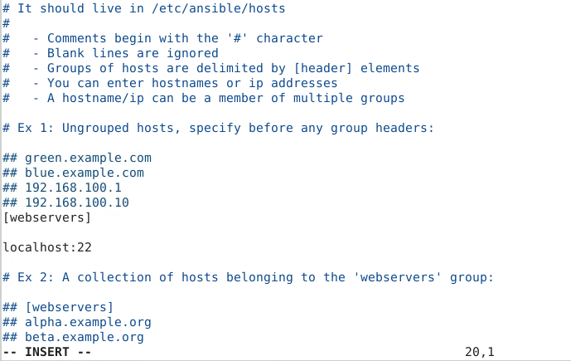
Step 2: Configure and validate the Apache web server setup

- Run the following command to edit the Apache configuration file:
sudo vi apache2.yaml

- Enter the following script into the apache2.yaml file:
---
- hosts: webservers
become: true
tasks:
- name: install apache2
apt: name=apache2 update_cache=yes state=latest

- name: enabled mod_rewrite
apache2_module: name=rewrite state=present
notify:
- restart apache2

handlers:
- name: restart apache2
service: name=apache2 state=restarted
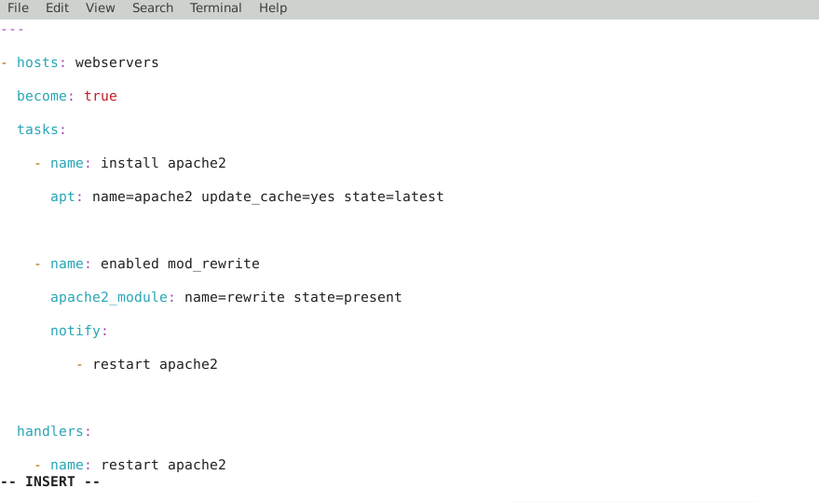

- Run the Apache installation playbook using the command below:
ansible-playbook apache2.yaml
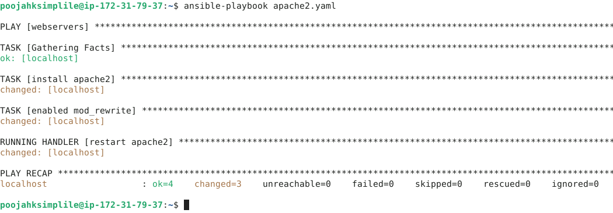
- Run the following Ansible ad hoc command to check the Apache server status:
ansible -m shell -a "service apache2 status" webservers
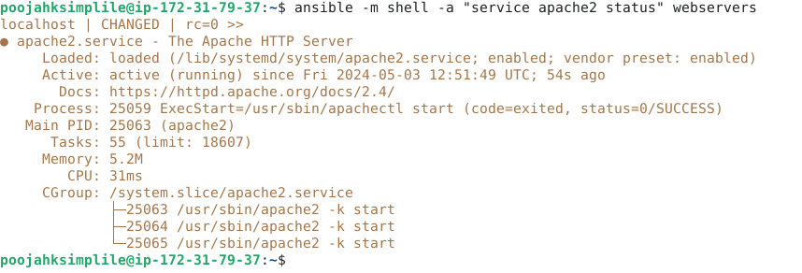
By following these steps, you have successfully configured and validated the Apache web server setup using Ansible on a local node machine for automated server management.

